If you do not already have access to the KSU Foundation Information Network (FIN), please complete the FIN Access Registration Form and return it to finsupport@ksufoundation.org who will either grant or deny access.

The following are written instructions with screenshots to provide guidance for accessing and using FIN.
- Log In credentials in “New FIN Access” email
- First time logging in to FIN - Set a password
- How To Access FIN > Campus-Reports > Accounting Reports
  - FIN Announcements
- Accounting Reports:
  - Expendable Register
  - Principal Cash & Pooled Fund Activity
  - Fund Balance Summary with Cash
  - Balance Sheet
  - Income Statement
  - Contributions Report
- KSUF Contact for any questions
- Frequently Asked Questions
  - FIN Access Registration Form – new or additional access
- Troubleshooting
  - Use an incognito or private window – Chrome or Edge
  - Reset your password

First time you log in to FIN
A “New FIN Access” email was sent to you with your log in credentials and quick instructions.
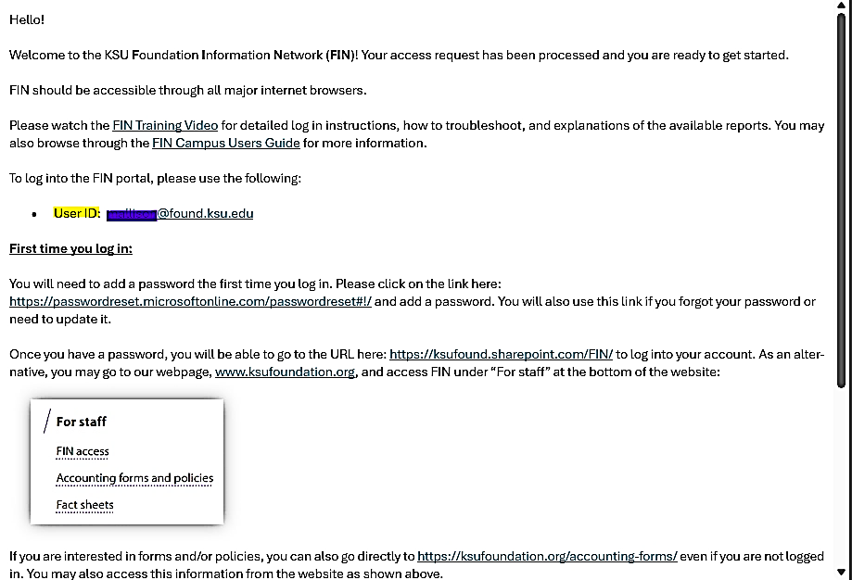

Set A Password
You will need to add a password the first time you log in. Please click on the link here: https://passwordreset.microsoftonline.com/passwordreset#!/ and add a password.
*** You will use this same link if you forgot your password or need to reset it. ***
Enter your UserID@found.ksu.edu in the first box. Please note that this is different from your campus login. After entering the characters from the picture in the second box, click Next. Enter your KSU email in the second box and click Next (see 2nd screenshot). A verification code will be sent to your ksu.edu email and will allow you to add/reset your password.
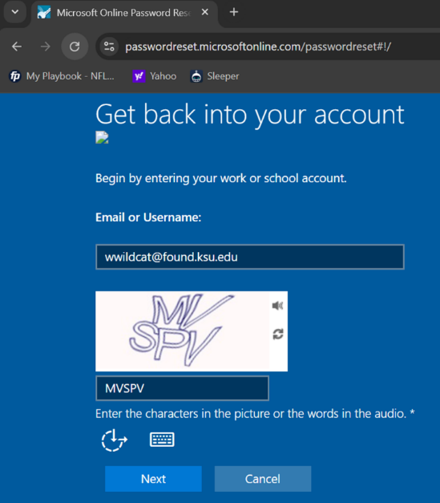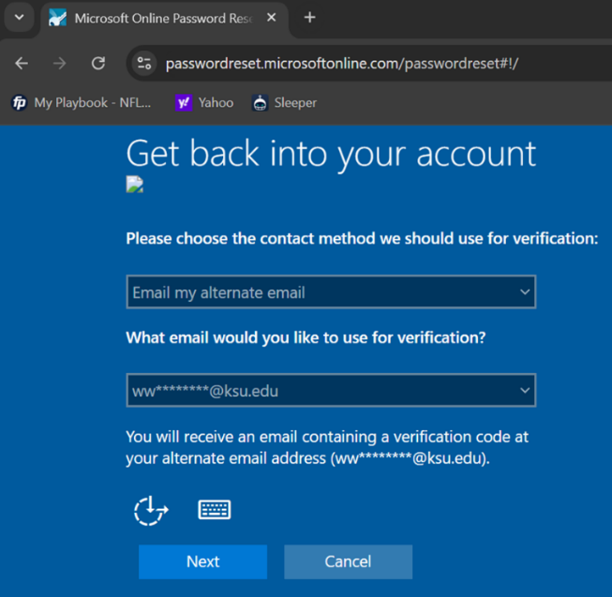

To Access the Foundation Information System (FIN)
FIN should be accessible through all major internet browsers. It is highly recommended to access FIN using an incognito window or private tab.
Before you proceed: Make sure you are connected to the university VPN.
There are two ways to access the FIN website.
- FIN Direct Link: https://reports.ksuf.net/Reports/report/Blackbaud/AccountingReports You may also access the FIN website by going to https://ksufoundation.org. Scroll down to Quick Links. Under “For staff,” click on FIN access (highlighted link below):
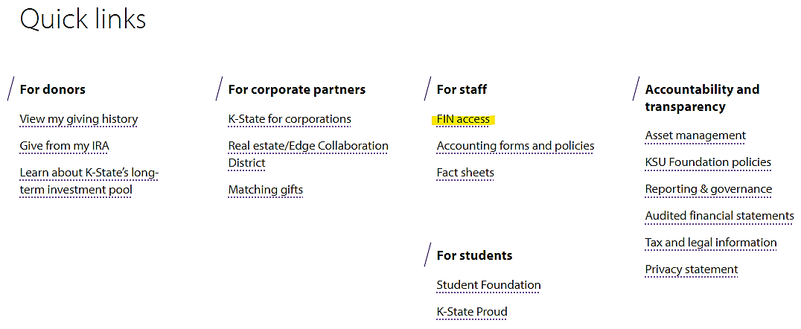
If you come across the error seen in the screenshot below, go to the Troubleshooting section in this Guide for further instructions.
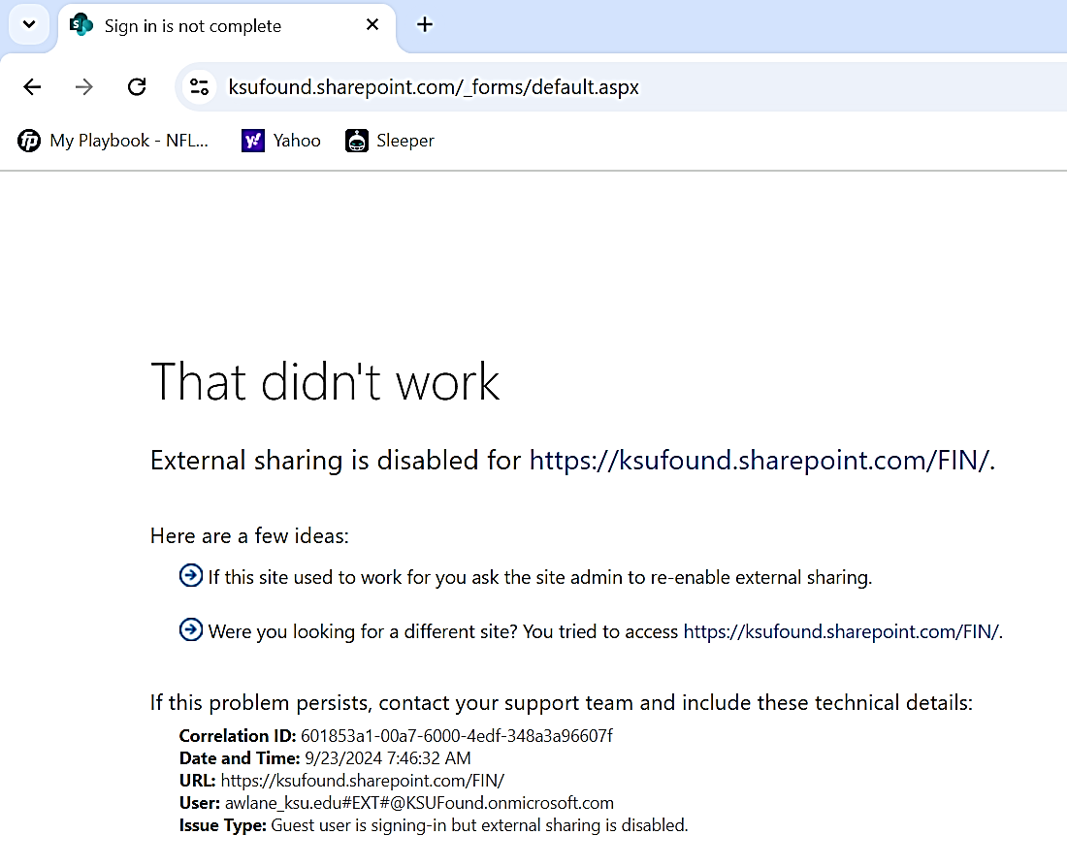
Sign in with your User ID and password. Once you are logged in, you will see the FIN Announcements on the home page.
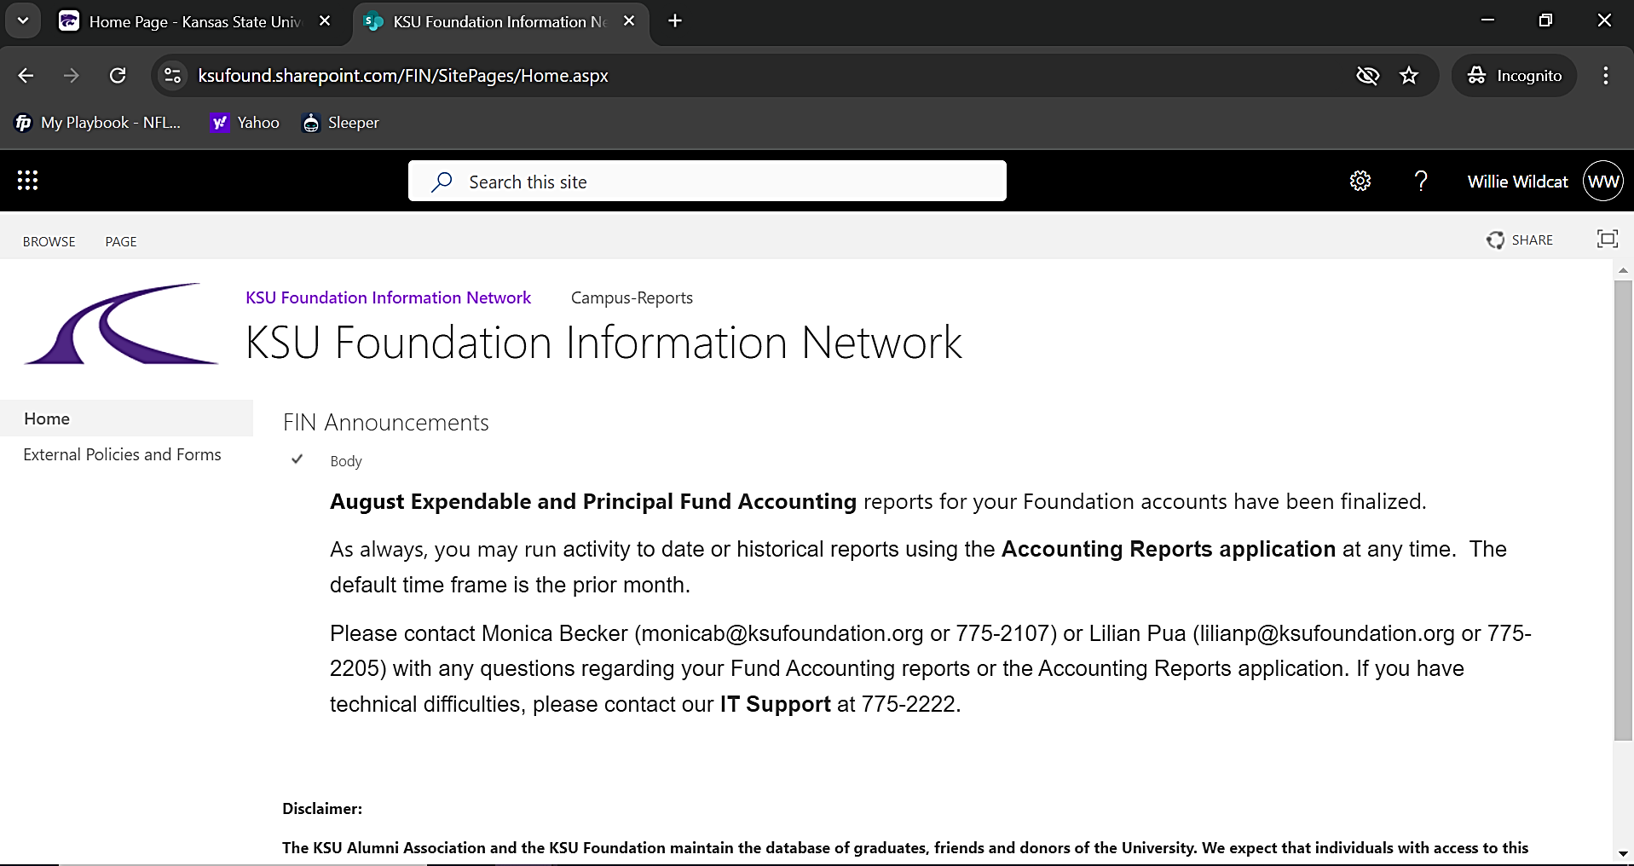
The Announcements will include which Fund Accounting reports are finalized. Generally, reports are finalized mid-month. For example, August reports are finalized by September 17. Note at the end of the quarter, the expendable reports are completed before the principal reports due to the principal revaluation and may be finalized at the end of month. Reports are always current as of the previous day.
Click on Campus-Reports at the top to access the FIN Reports. Generally, the following reports will be available. Click on Accounting Reports.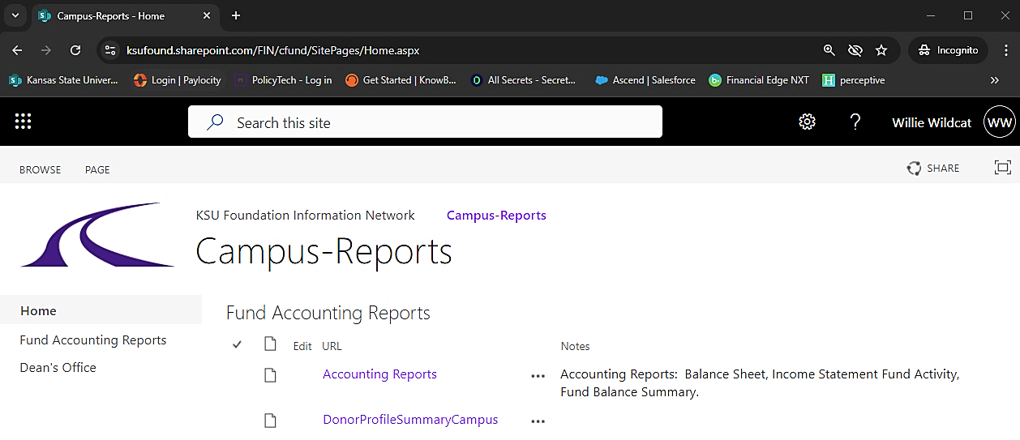
The first time that you access the reports, you will be required to enter your credentials a second time (also when using an incognito window). Enter your Username UserID@found.ksu.edu in the top box followed by your password in the second box.
Chrome:
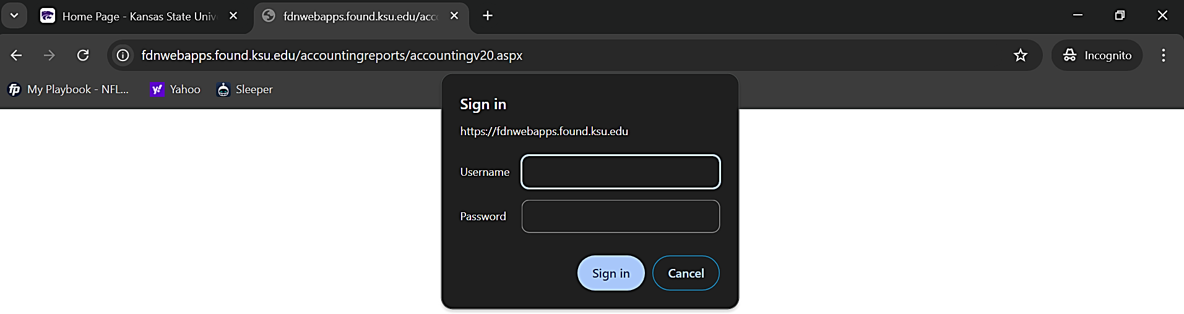

Edge:
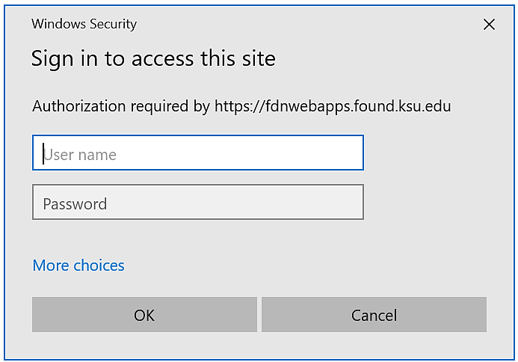

Accounting Reports
A variety of Accounting Reports will be displayed as seen.
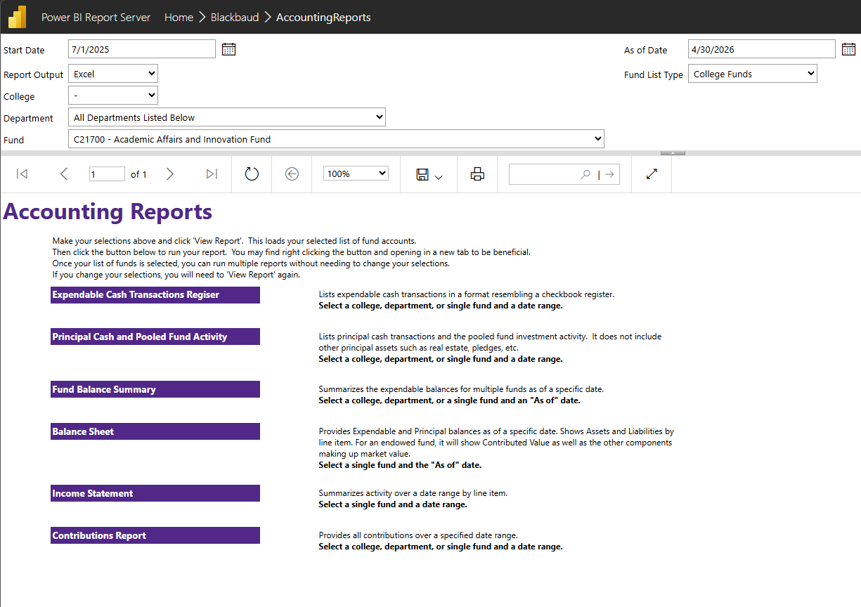

Please note that the default output is Excel, but the reports can also be exported to PDF. The reports default to the last month that has been finalized. The date range can be defined over any period as far back as 7/1/1997 to the current month end. In all cases, the user must make at least one selection from the College/Department/Fund list.
When running any of the reports, the output will provide several key pieces of information at the bottom:
The most recent date that the Foundation’s Pooled Fund was valued (always the end of a quarter), the most recently closed date for the principal reports (one should not expect additional principal entries after the closed month), the most recently closed date for expendable reports (the user should not expect additional expendable activity after that month), and the run date. This information is important in interpreting your reports. It will be visible in PDF format but not visible in Excel until the report is ready to print.

A more complete description of each of the reports follows.
Expendable Cash Transactions Register (By College/Department/Fund): This report lists expendable cash transactions in a format resembling a checkbook register in a given fund or department or college as of a specified date range. This will reflect cash transactions only, so gifts in kind will not be reflected and the amount realized by securities gifts may differ from the amount for which the donor was receipted. It will provide a running cumulative cash balance available for expenditure.
Principal Cash and Pooled Fund Activity (By College/Department/Fund): This report lists principal cash transactions and the Pooled Fund investment activity. It does not include other principal assets such as real estate, pledges, etc. It shows any contributions to principal as well as earnings reinvestment and Pooled Fund market revaluation.
Fund Balance Summary with Cash (By College/Department/Fund): This report summarizes expendable and principal balances for all funds in a given department or college as of a specified date. It can also be run for a single specified fund. The first and third columns show only cash and Pooled Fund assets. The second and fourth columns include items such as pledges, life insurance CSVs, Real Estate, etc. When run in Excel format, this report also provides additional information on the attributions of a fund (so would be sortable for scholarships vs. excellence). The total (fifth column) is the total of all assets including the non-cash items.
Balance Sheet: This report provides expendable and principal balances for a given fund as of a specified date or all funds in a given department or college. For funds in which the Fund Balance Summary balances differ, this will show which items account for the difference. In addition, it provides detail regarding the Assets, including Contributed Value, non-Contributed Value, and Unrealized Gain/Loss for the Pooled Fund Investment which can be used to determine the underwater position of an endowment. It will also show expendable cash as well as any principal cash that will be invested in the Pooled Fund as of the next quarterly cycle.
Income Statement: This report summarizes the Revenue and Expense activity over a specified date range by accounting line item for a given fund or all funds in a given department or college, differentiating by Income and Principal. It also shows the resulting ending balance of each segment of the fund. This can be used to track fund utilization over a period of time.
Contributions Report: Provides donor information, as well as additional gift information on all contributions over a specified date range. This can be used to reconcile which gifts make up the summarized contribution entries to the funds on the Expendable Cash Transactions Register and Principal Cash and Pooled Fund Activity reports. It should not be used to contact donors or for Honor Rolls.

KSUF Contact
If you have further questions regarding any transactions or have any issues with accessing FIN, please contact finsupport@ksufoundation.org for assistance.
When emailing, please provide screenshots of your issue or error message. For reporting questions, please provide the fund number, date, and amount of the transaction. Screenshots with the name of the report and the date range used are very useful in helping to research and the response time.

Frequently Asked Questions (FAQs)
Question:
Where can I find the FIN Access Registration Form?
Answer: There are two ways to access the form.
- Direct Link FIN Access Registration Form

- Another way to find the form is on the Accounting Forms page.
Direct Link https://ksufoundation.org/accounting-forms/
- Go to the KSUF Home Page at https://ksufoundation.org , scroll down to Quick Links. Under “For staff,” click on Accounting forms and policies.
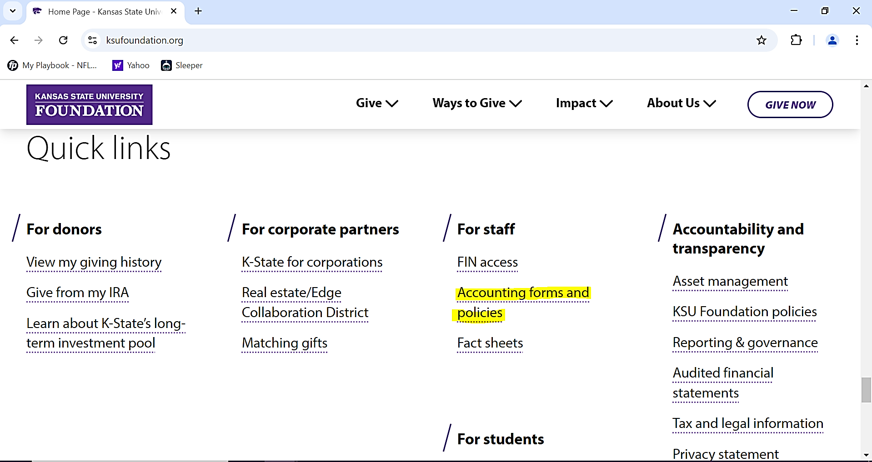
Feel free to browse through the various KSUF Accounting Forms that are available.
For FIN related items, scroll down to the bottom under Other.
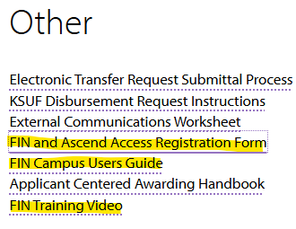
Whether you are new to FIN or would like to add another fund or department to your current access, please complete the form, obtain approval signature at the bottom, and send to finsupport@ksufoundation.org for processing.
The user’s email on the form will be added to the FIN Contacts address book to receive FIN email notifications.
- A New FIN Access welcome email will be sent to new users with their login credentials and quick instructions.
- A FIN Additional Access email will be sent once additional access has been granted.
Please note that Foundation account fund numbers are alpha numeric with one letter followed by 5 digits.
Example: N12695 AR – R&S DIGITAL SERV INC SCH
Foundation department codes are only 4 digits. You may write out the department name if you do not know the code.
Example: 5006 The Office of Student Financial Assistance

Question:
I know we received gifts on this certain date. Why am I not seeing these in the Expendable Cash Transaction Register?
Answer:
It could be that the fund is endowed. You should try running the Principal Cash and Pooled Fund Activity Report. Also, Gifts in Kind will not affect your cash balance.
It could also mean that a request was made either by the donor or a staff member to adjust the gift from one fund to another. You might try expanding your date range further into the future.
Adjustments will look like this: CA 5-19-17 SMITH X12345/Y98765. This represents a Contribution Adjustment where the original gift came in on 5-19-17 for a donor by the last name of Smith and was moved from the fund X12345 to fund Y98765. Adjustments are reflected in the financial statements when the adjustment is made but in Ascend as of the date of the original gift.
Question:
How do I know what a Non-Contribution Deposit is?
Answer:
In most cases, this would have been a result of a KSUF-4 submission. However, in the event that the Foundation directly receives a deposit that has no charitable component, such as a check through the lockbox for an event, it will be necessary to contact us to get additional information.
Question:
Why do I have a UAF fee without a gift?
Answer:
This is likely a Security sale. The UAF is recognized the date that the gift is reported to our database based on the amount for which the donor was receipted (the average stock price that day for the security). The cash is realized when the stock is sold, which could be earlier or later, and also is made for that actual amount of the sale.

Troubleshooting
> > > Required: Make sure you are connected to the university VPN. < < <
Use an Incognito Window to access FIN
- It is highly recommended to use an Incognito Window or Private Browser to log in to FIN (black window).
Keyboard shortcut Open a window of your preferred browser. Ctrl + Shift + N
Mouse shortcut Open a window of your preferred browser. Right click on Chrome or Edge icon on the taskbar at the bottom of the screen and look for either “New Incognito Window” or “New InPrivate window.”
Chrome:
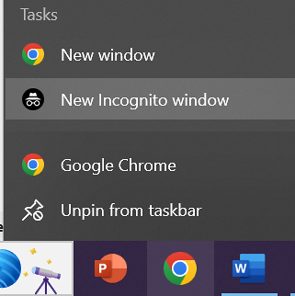
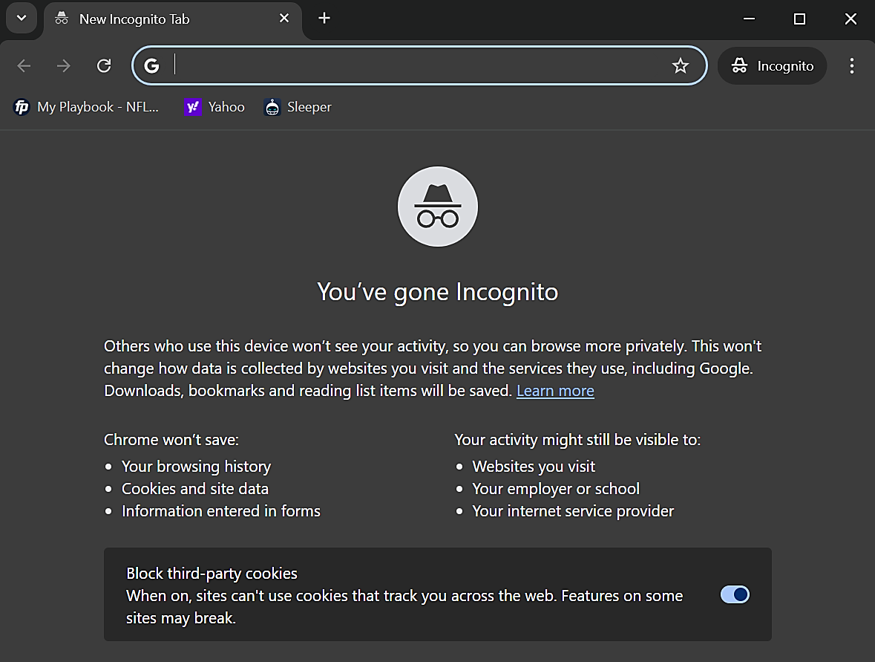
Edge:
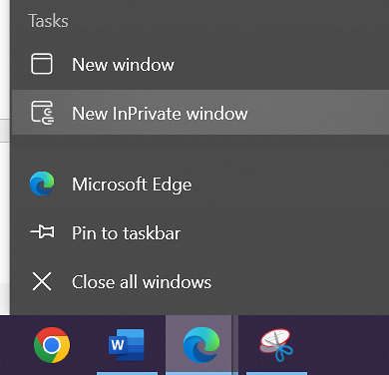
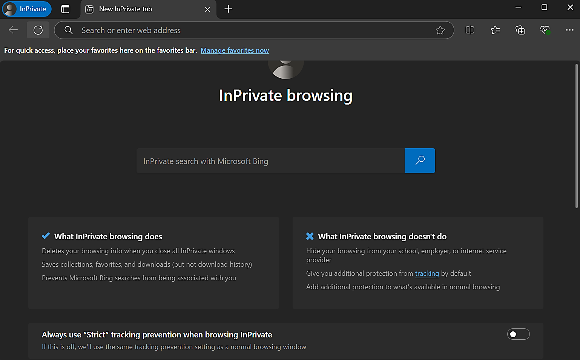

- Copy and paste the FIN link into the browser https://reports.ksuf.net/Reports/report/Blackbaud/AccountingReports
- Enter username and click Next. Enter password and click Sign In.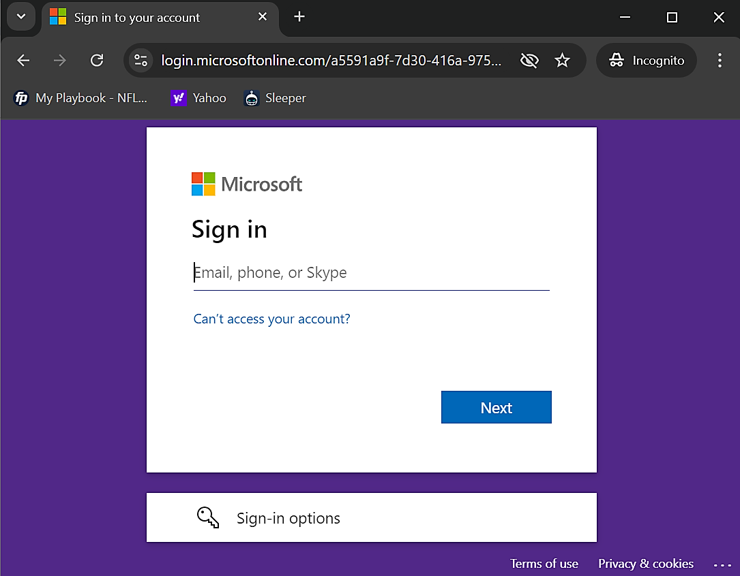
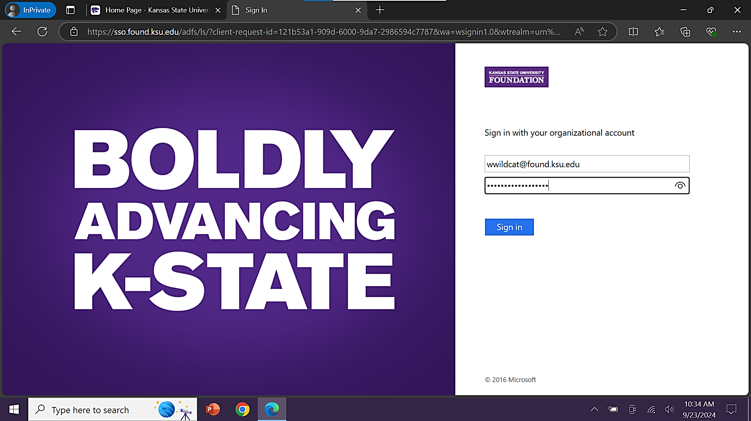
- Stay signed in? Select No or Yes. This should take you to the FIN Announcements on the home page.
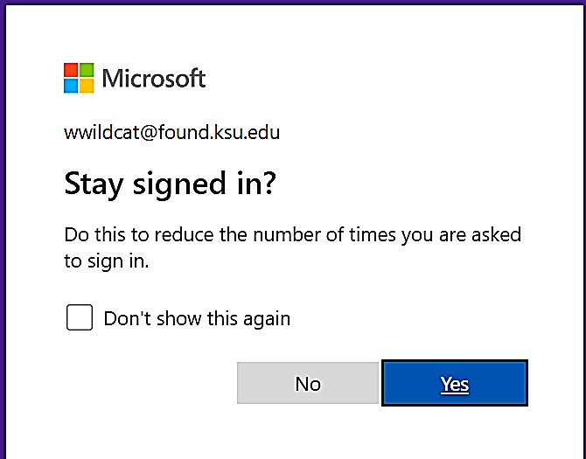
- Click on Campus-Reports, then Accounting Reports. Enter your credentials a 2nd time.
Chrome:
Edge:
- This should take you to the Accounting Reports screen.

Reset Password
If you were unable to access FIN using an incognito window, please reset your password.
Password Reset Link https://passwordreset.microsoftonline.com/passwordreset#!/
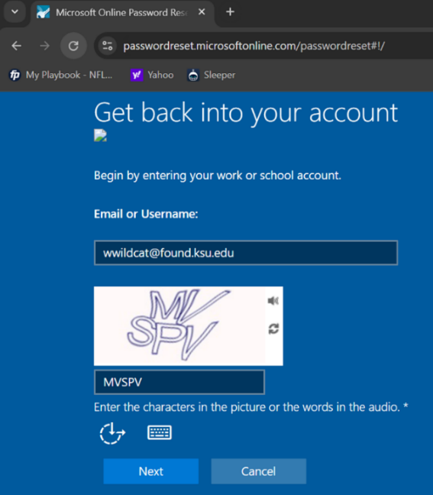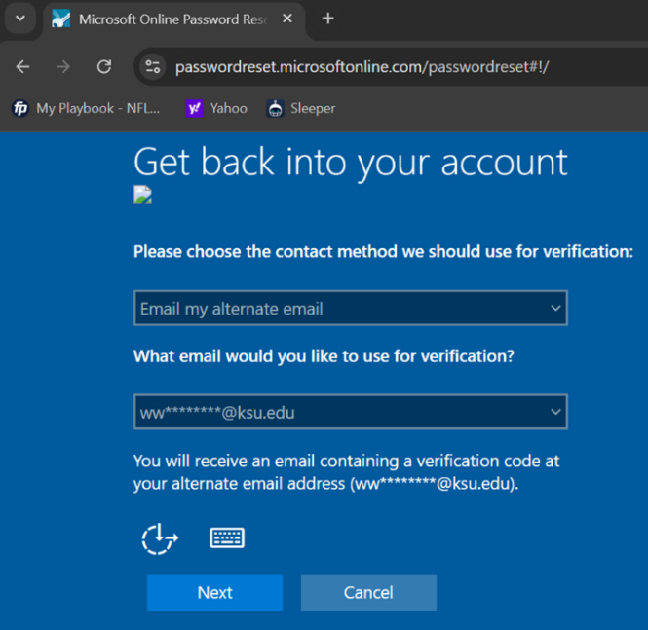
Note that your FIN username is not the same as your KSU login – it must include @found.ksu.edu and would normally be the first initial of their first name and full last name (example: Willie Wildcat is wwildcat@found.ksu.edu). In the 2nd screenshot, enter your KSU email and click Next. Check your campus email for a verification code that will allow you to reset your password.
If you are still unable to access FIN after the above steps, please try to clear your history and cache in your internet browser.
If you are still unable after following the above steps, please reach out to finsupport@ksufoundation.org.

